## Remote Palliative Care – Iteration 1

## General Data Protection Regulation (GDPR)

### Overview

GDPR is based in the UK and is a regime that applies to businesses that acquire and hold personal information about European residents.

The UK GDPR sets out seven key principles:

* Lawfulness, fairness, and transparency
* Purpose limitation
* Data minimisation
* Accuracy
* Storage limitation
* Integrity and confidentiality (security)
* Accountability (ico, 2022)

Here in New Zealand, we don’t need to comply with GDPR because it is European law not New Zealand law but because the palliative care system may be holding delicate information about a European citizen then the system must comply with the GDPR.

By complying with the New Zealand privacy act, it gets you extremely close to complying with GDPR, the one thing that the NZ privacy act lacks is it does not express data portability. (privacy, 2022)

### Implications

All organizations and companies that work with personal data should appoint a data protection officer or data controller who oversees GDPR compliance.

There are tough penalties for those companies and organizations who don’t comply with GDPR fines of up to **4% of annual global revenue**or**20 million Euros**, whichever is greater.

### How it Complies

For this iteration the Remote palliative care database does not comply with New Zealand privacy act let alone the GDPR regime. I have not made any security measures to insure it does comply.

**What I will need to implement in future iterations:**

* Create different roles and users with different privileges and rights regarding accessing sensitive data.
* Encrypt all sensitive data, especially when exporting.
* All users will need to give consent before handing over their personal information and will be given clear advice regarding how they can access for viewing or updating it at any time.

## Design/Analysis

### Noun analysis

|  |  |  |  |
| --- | --- | --- | --- |
| Patient | Carer | Worker | Contact |
| Name | Name | Name | Date of contact |
| Title | Title | Title | Reason for contact |
| Address | Address | Address | Actions taken |
| Phone number | Phone number | Phone number | Contactor |
| Gender | Gender | Gender |  |
| DOB | DOB | DOB |  |
|  |  | Availability |  |

### Normalisation And Entity Relationship Diagram



File Path: " \ERD and Normalisation.vsdx"

### Assumptions

**Patient –** The patient could have many carers.

**Carer –** The Carer could have many Patients.

**PatientCarer –** Because of the many to many relationship a bridging table is needed. Some additional attributes that would be good to record would be the relationship between the carer and patient, the time the carer started care and if the carer is the patient’s primary carer.

**Worker –** To keep this iteration simple I have just made the worker be a person with similar attributes to carer and patient with an extra attribute (availability) and only one contact phone number.

**Contactor –** can either be a Carer or a Patient so this table has a contactor number as primary key and both patient and carer as a nullable foreign key as it can only be one of them.

**Contact –** needs date of contact, reason for contact, the actions taken the patients number the workers number and the contactor.

## Code

I chose to create the database in MYSQL and generated dummy data from generatedata.com

### Show Tables

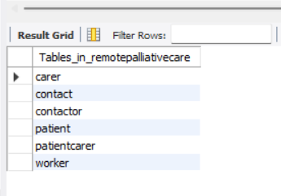

### Patient

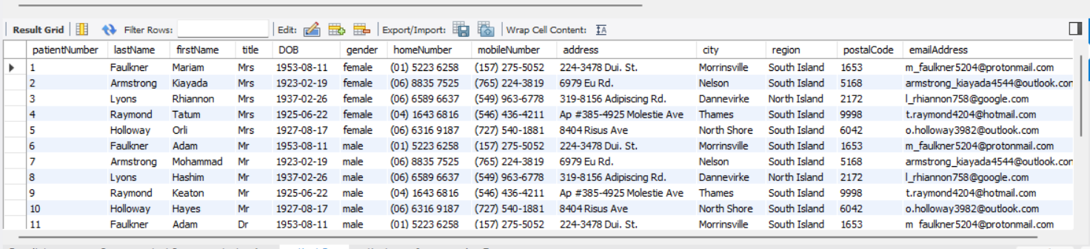

### Carer

### PatientCarer

### Worker

### Contactor

### Contact

### Queries

**Q#1 Check what patients had contact to certain worker and why**

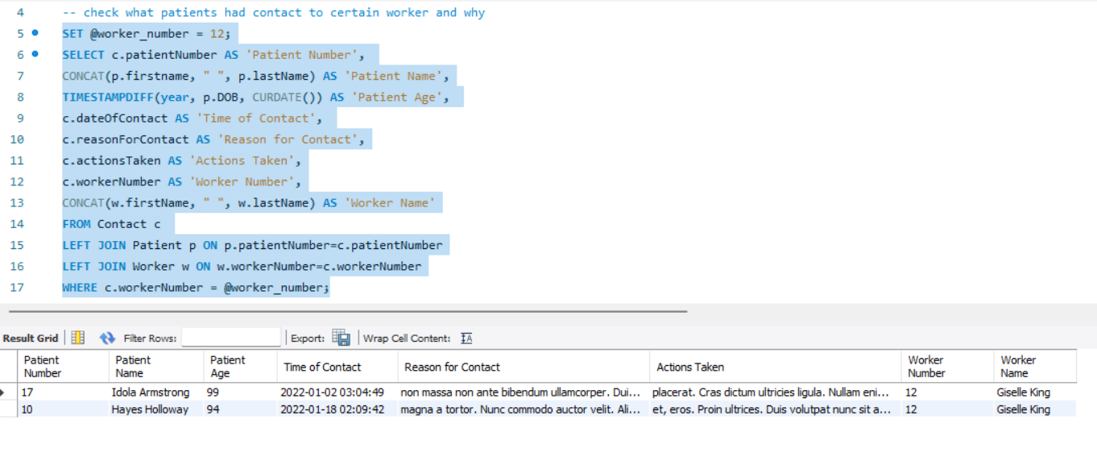

**Q#2 The percentage of contacts made by patient region and average patient age (for some reason when I generated the data the only regions for New Zealand were North and South Island)**

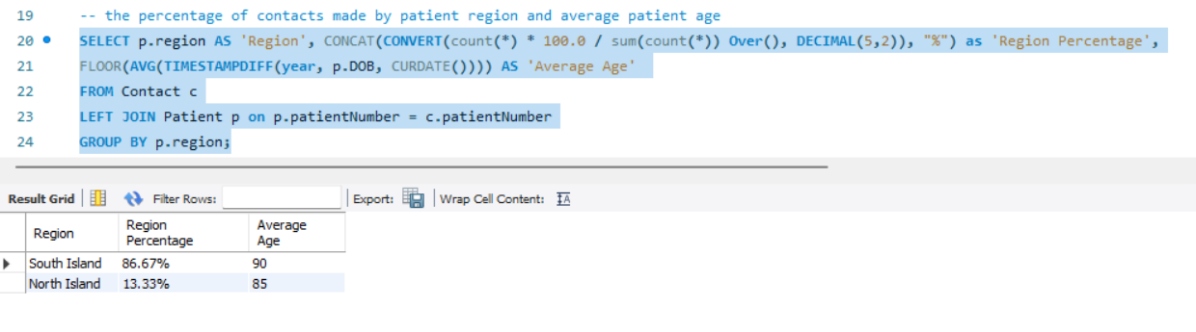

**Q#3 Primary Carer for certain patient**

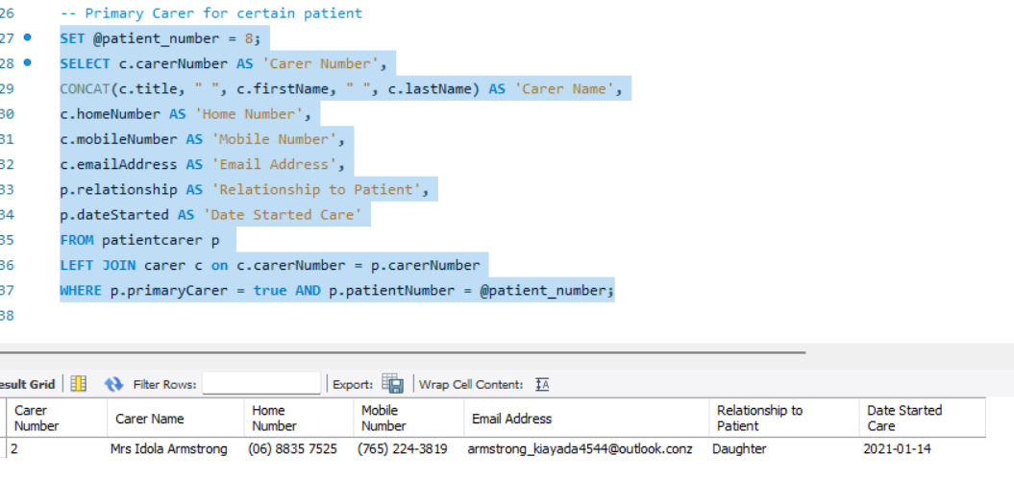

## Back up, Restore, Security and Role Management

### Backup

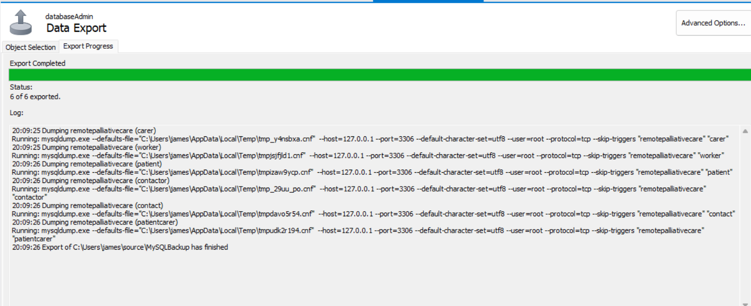

### Drop Database

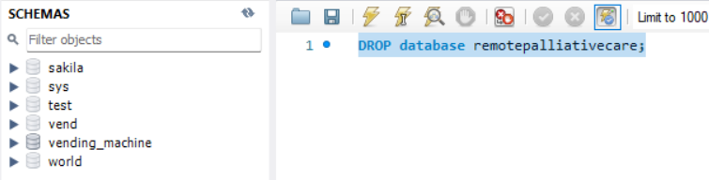

### Restore

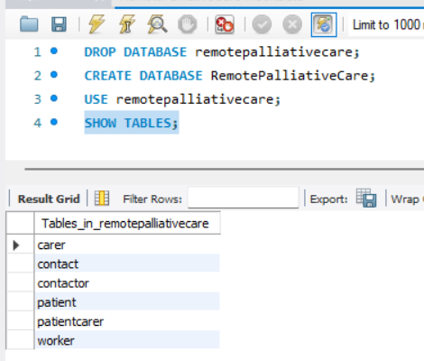

### Security & Role management

For this iteration I haven’t implemented any security or role management. Iteration 2 I will be planning to do this.

## Performance Review

### What worked well

**Design –** Noun analysis was good I didn’t want to get too out of hand for the first iteration regarding the number of attributes that would be required. The table set up and ERD was relatively quick to implement.

**Code –** Creating the database was good once I started it everything, I learnt from database design class came flooding back so was quick to do this stage, I think the queries I done are insightful and would be used in different areas of the healthcare sector.

**Backup –** was easy and I done this quick.

### What didn’t work

**Design –** I had trouble with generating the data when it came to linking the patient to the carer for the contactor table it took quite a while because after generating, I had to change so it would match the patient Number to the right carer.

**Code –** I took awhile to think of the queries so they would be good enough and retrieve insightful information.

**Security –** I didn’t implement any security but that was part of my plan, anyway, waiting for next iteration.

### What I would do next time

Regarding this iteration not much because I wanted to leave some things to do for the next iteration, but I would bulk insert data from file instead of inserting into table. I will rectify this on the upcoming iterations.

# References

ico. (2022, 08 10). *guide to GDPR*. Retrieved from ico.org.uk: https://ico.org.uk/for-organisations/guide-to-data-protection/guide-to-the-general-data-protection-regulation-gdpr/principles/

privacy. (2022, 08 10). *knowledge-base*. Retrieved from privacy.or.nz: https://www.privacy.org.nz/tools/knowledge-base/view/482